Article for the May 19, 2016 edition of the Herald News Living Well Section

Fitness Challenge Weight Loss Winners can teach all of us!
While everyone likes to win a door prize drawing or a lottery ticket, when little to no effort is required, winners of the annual Greater Fall River Fitness Challenge really had to work to earn their prizes! Dozens of individuals and team members as well as public schools competed in the annual event to earn thousands of dollars in cash prizes given out each year by Partners for a Healthier Community and demonstrated that anyone can improve their health if they’re willing to put in some time and effort.
Perhaps the most impressive competitors were the over 5,500 school children among sixteen schools who each participated in some aspect of the school challenge. That part of the Challenge asked physical education teachers to come up with some kind of activity that would engage children in healthy activities beyond what they get in their physical education classes. Entries ranged from modified cross-fit workouts, to strength testing programs, to yoga projects, to walking contests, each designed for every student, not just those who excelled in physical activity. This year’s winning upper level school was the Kuss Middle School who not only put an exercise program together but also created clever music videos to promote the program.
For the first time, this year’s Finale included the award of an overall Excellence Award given in the name of Bill Daponte, the man who originally conceived of the Fitness Challenge who passed away earlier this year. That award was given to Silvia Elementary School Physical Education Teacher Terry Mahjoory who planned and orchestrated over a dozen different brief physical activities that take place over the school day either for the first two minutes of classes or during times when children are lined up in the hallways waiting to use the bathrooms. “What Terry has done in that school is to integrate physical education into the entire day so that children get the advantages of physical activity that has demonstrated benefits for mental and emotional health,” noted Partners School Wellness Coordinator Marcia Picard.
What the children’s portion of the Challenge can teach all of us is the importance of integrating movement into all parts of our lives. With jobs that more often require people to sit for long hours in front of a computer screen, we should all take note of the benefits that taking physical activity breaks at least every thirty minutes can have. Recent research is demonstrating that measureable reductions in obesity, heart disease and diabetes rates can be achieved through these brief but intense bursts of activity that increase resting heart rates and improve circulation.
The winners of the adult weight loss part of the Challenge competition also have some important lessons to teach. Both male winner Lance Tehan, who lost over 11% of his total weight, and Danika Guadalupe, who lost almost 20% of her total weight, used the same approach to weight loss that was recommended in the nutrition education classes that ran every Saturday as part of the Challenge at Kuss Middle School. Though neither contestant enrolled in the classes, each confirmed that they lost weight by reducing carbohydrates and not dietary fats. This is the approach that has been demonstrated by study after study to achieve both the best short and long-term weight loss.
“My wife was one of the teachers in the class,” noted Lance. “So I didn’t have to attend because she was showing me every day that cutting out sugar and processed foods was all I had to do to lose weight,” he added. Though Lance got in some moderate exercise once or twice a week, it wasn’t the exercise that led to the weight loss; it was getting off the carbs. “I didn’t believe it would work so easily until I tried it,” he added.
Danika also lost her weight primarily due to changes in her diet, including cutting out fast foods and soda. “I learned to drink water instead, and that made a big difference,” she said. She also cut down on the carbohydrates at home and ate primarily meat and vegetables. While exercise was also part of her prize-winning routine, it accounted more for loss of inches rather than pounds as her muscles became more firm. “Because I was captain of my team at People Incorporated, I really had to make an effort, and it paid off in a big way,” she added.
When we start the challenge, I give everyone a hand-out that states “While exercise can help you maintain weight loss, in order to lose weight, you have to change what and how you eat.” Exercise will lower your risk of developing heart disease, stroke, high blood pressure, diabetes, back pain, arthritis, osteoporosis and some cancers, but don’t count on it to take off the pounds. To do that, you have to eat foods that don’t stimulate insulin, and that’s primarily refined grains and sugars. To replace those calories, you also need to increase your intake of healthy fats including foods like olive oil, coconut oil and butter. While this isn’t the advice that most of us have heard, the science is now very clear that this is the approach that leads to healthier weight and improved cardiovascular health than trying to restrict calories or fat and ending up hungry.
So, there’s a lot that this year’s Challenge winners can teach us both about the importance of regular physical activity and the value of changing the foods we eat that can lead to healthier lives. For more information on low-carb diets, go to www.gfrpartners.com/LowCarbs.html or contact Dr. Weed at drweed@cox.net.
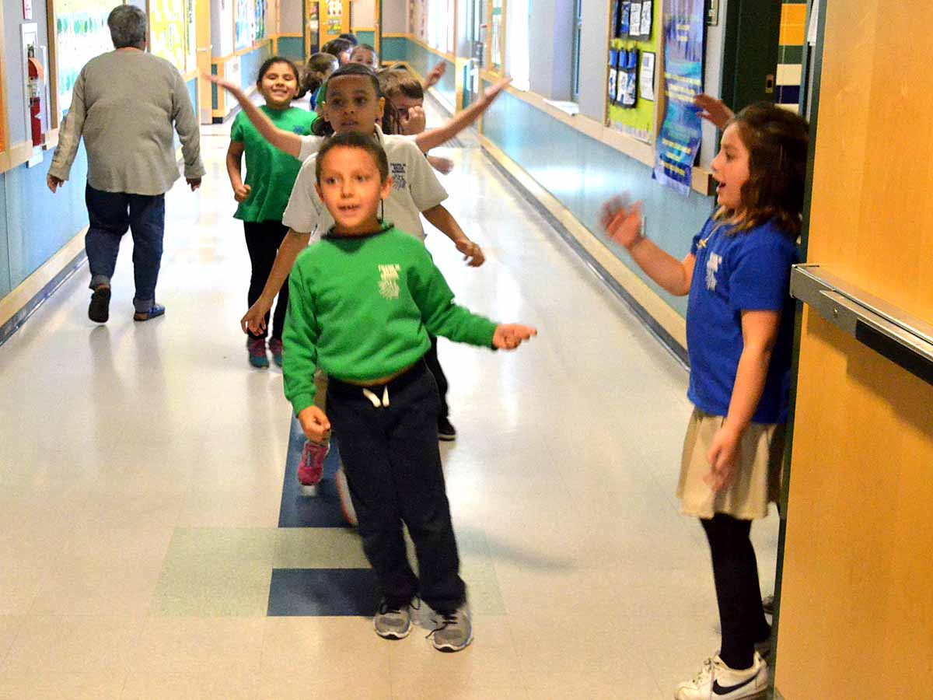
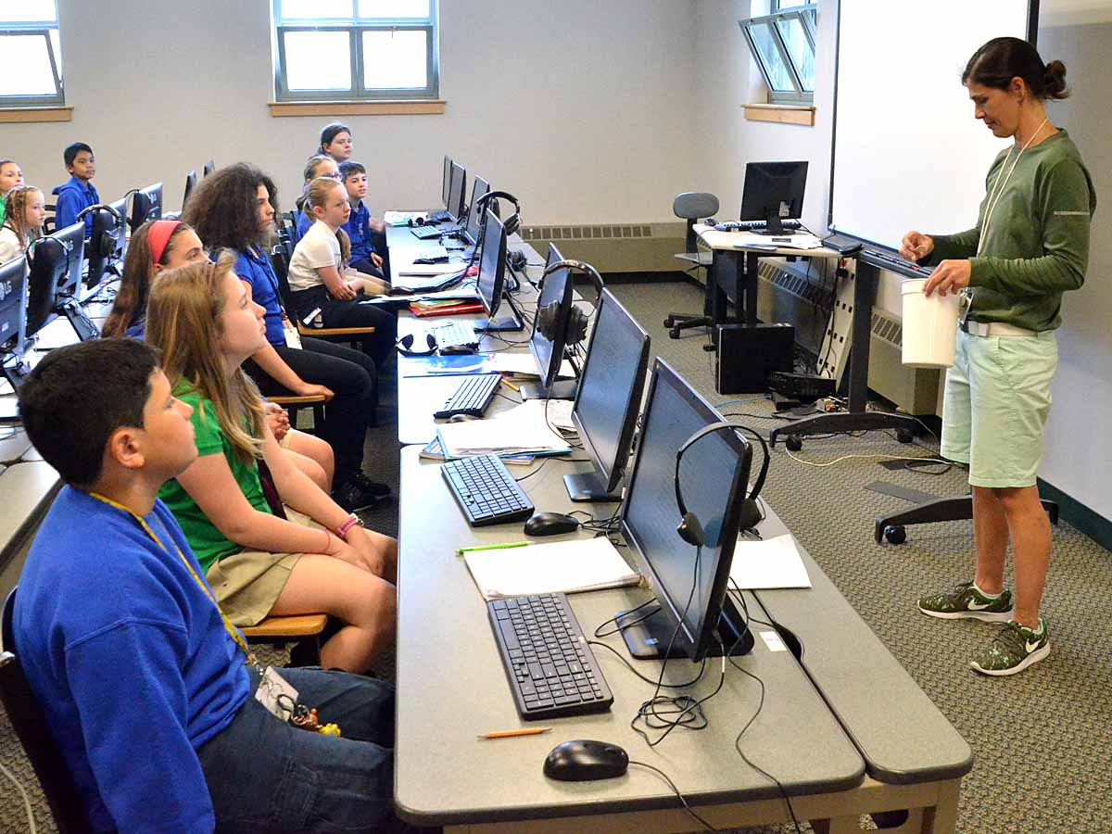
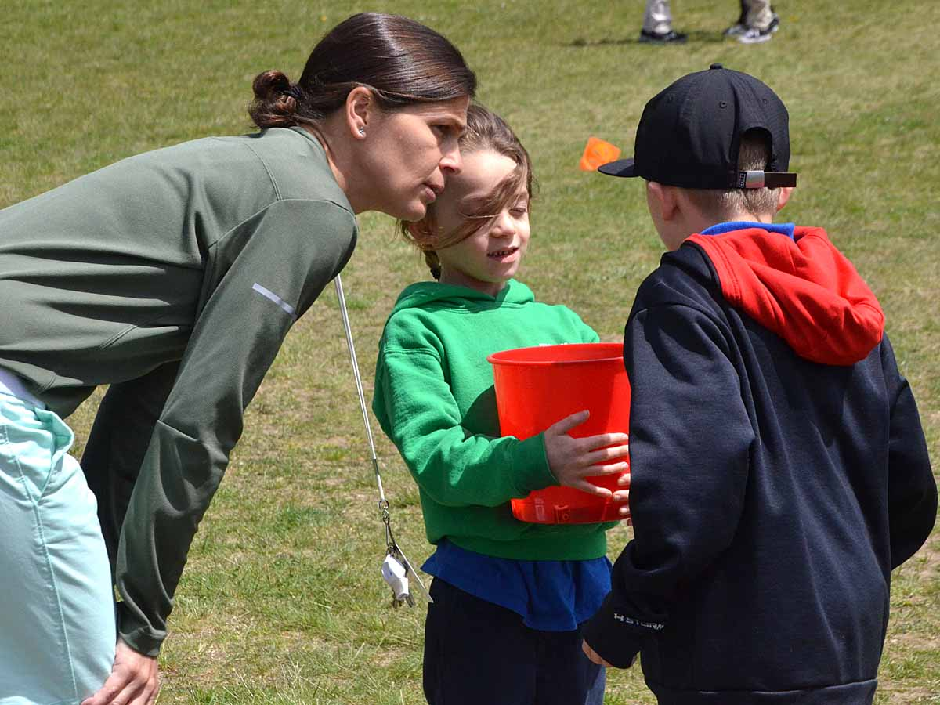
(Above 3 photos) Silvia Elementary School Physical Education Teacher Terry Mahjoory encourages physical activity throughout the school day in the hallways, the classrooms and on the playground .

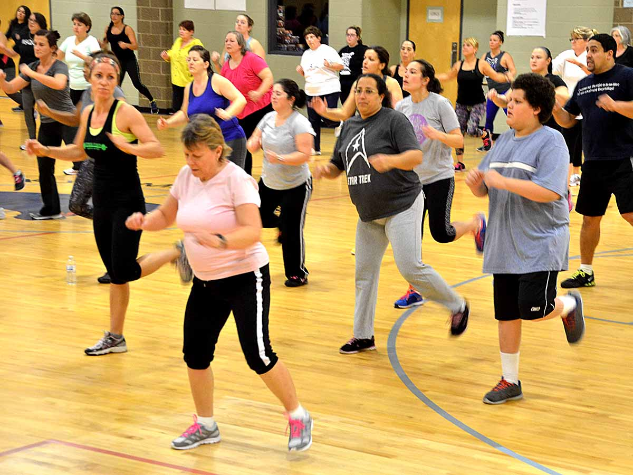
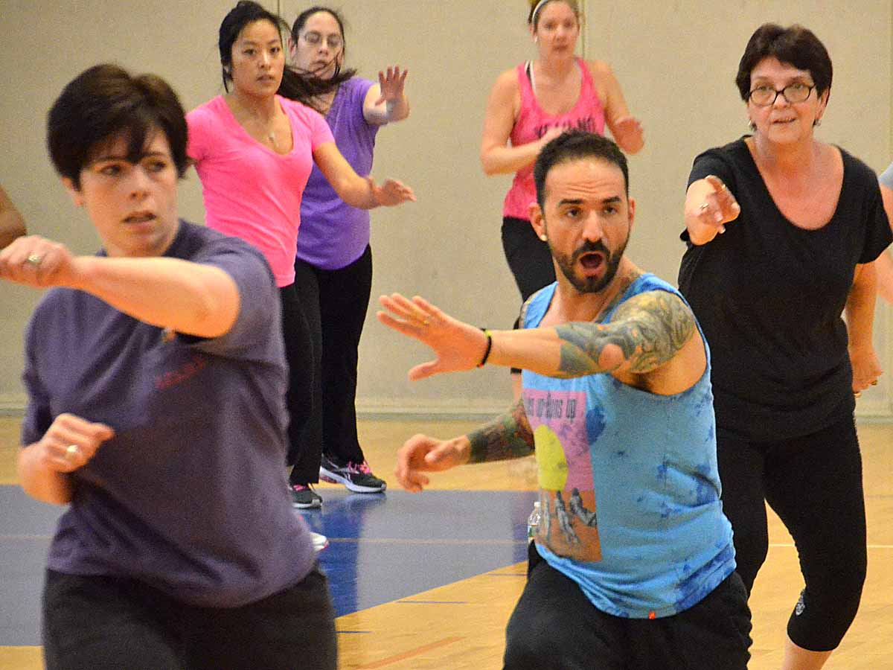
(Above 3 photos) Winners of the 2016 Fitness Challenge pose for a group photo at the Finale and are pictured at several of the Challenge events. (All photos by David Weed)

